Class Diagram:
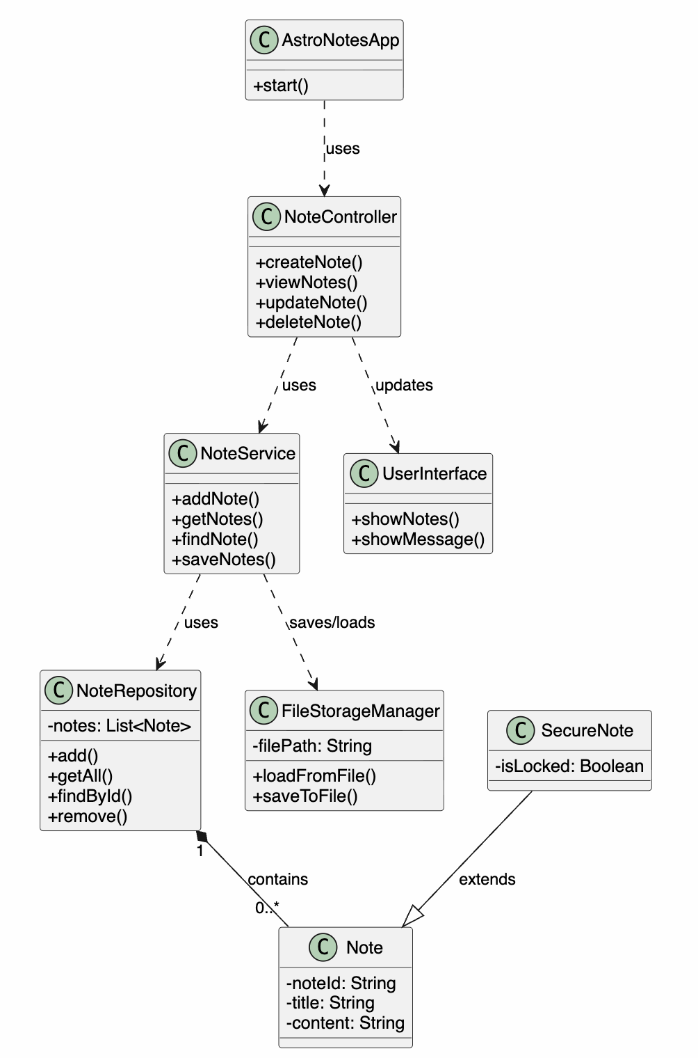
Object Diagram: 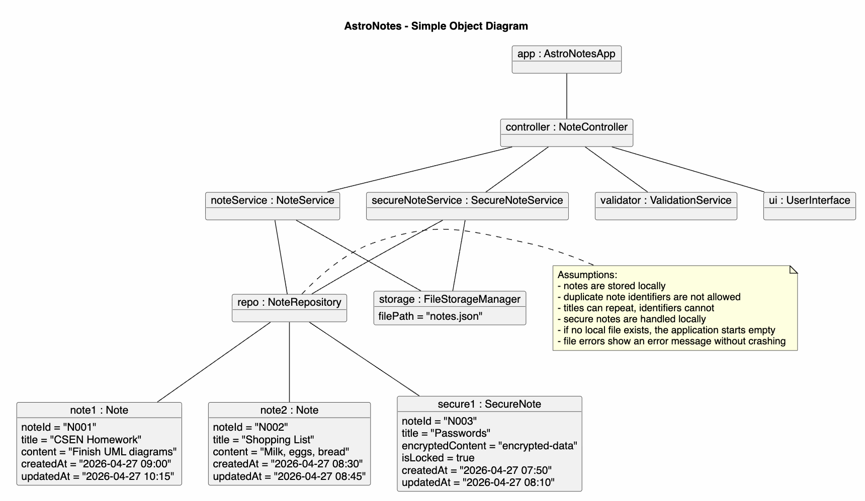
Use Case Diagram:
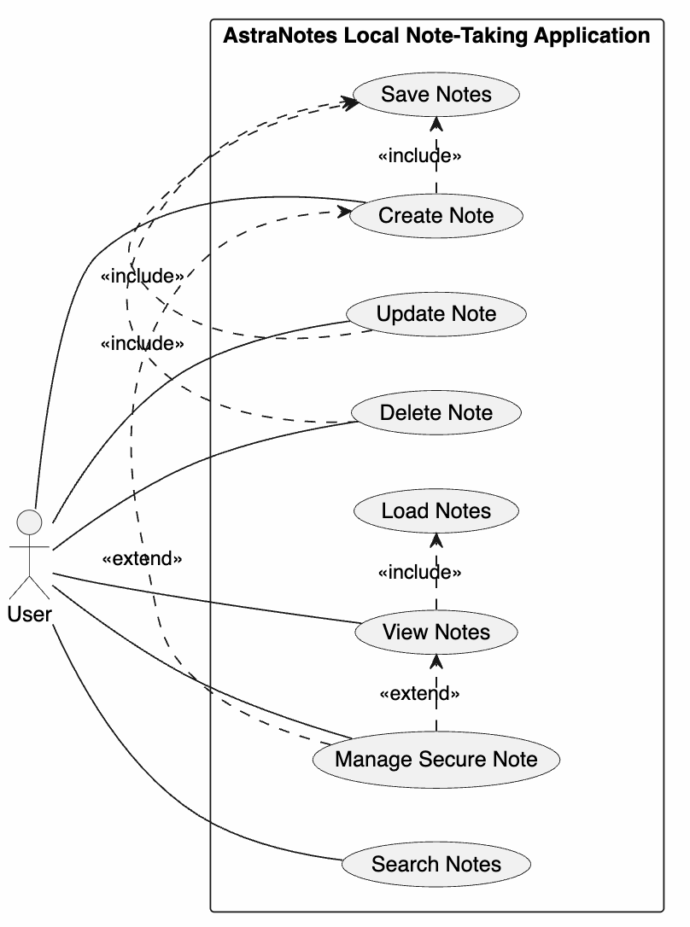
Activity Diagram: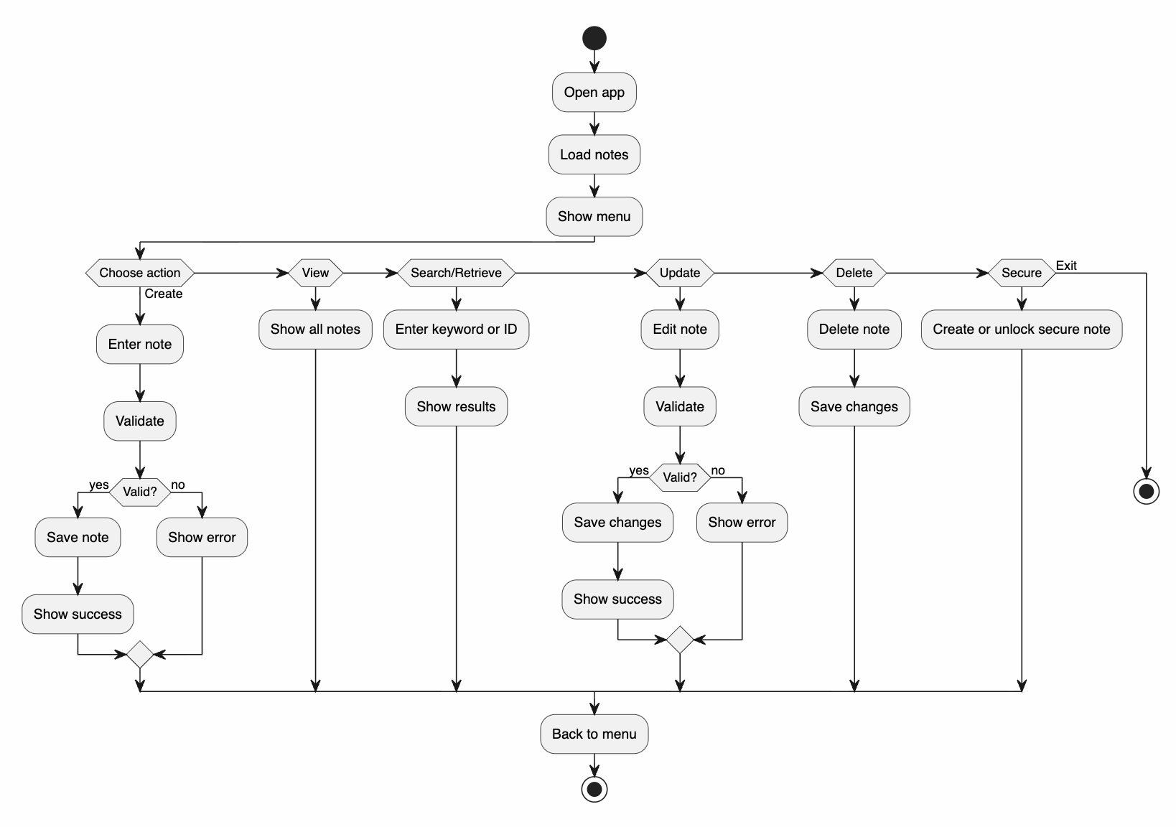
Deployment Diagram:
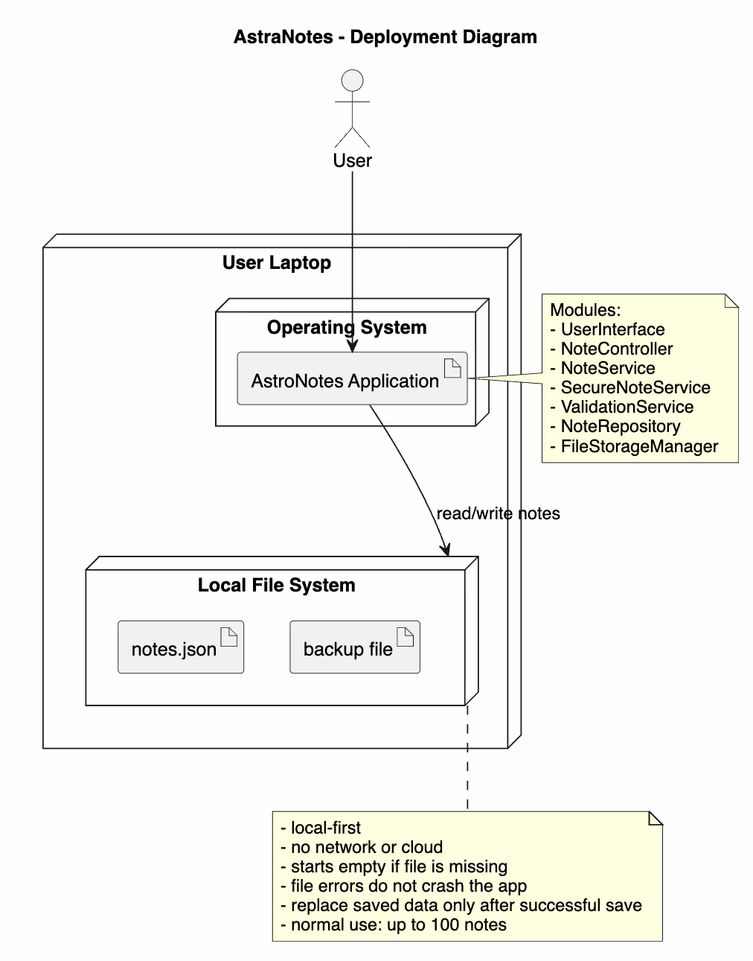-

Short written rationale: All of these diagrams go hand in hand with each other to show and show the project in different forms but at the end of the day they are connected and show an entire system working together. The use case diagram shows wht the user has the options do. The activity diagram shows the actions flowing and can show things such as error handling and saving. The lass diagram shows how the structure of the system by showing how different components such as storage and notes interact. The object diagram shows how the classes look when running with data that would be used. The deployment diagram ties everything together by showing where the system will run and how it will interact with the file system. Bringing it all together threse views clearly show consistency between how the system works, users, and setup all go hand in hand.

